JNJ AND COKE ANALYSIS
Name:
Tutor:
Institution:

Introduction
The Coca-Cola Company is a corporation in America, a manufacturer, marketer and retailer of non-alcoholic beverage syrups and concentrate. The company is popular for its flagship in providing Coca-Cola products). The company was invested in the year 1886 by John Pemberton who is a pharmacist in Atlanta, Georgia. The company is headquartered in Atlanta. The company has an operated as a franchised system since 1889. The stock of the company is listed in NYSE. In 2015, Coca-Cola Company that was found to be a valuable brand immediately after google and apple. In 2013, Coca-Cola products were globalized to 200 countries across the world. The drink's name is initiated form its source ingredients; lime, lemon, coffee, Coca-Cola Vanilla, Coca-Cola Cherry, Coca-Cola zero sugar, coke caffeine-free and caffeine free Coca-Cola. The main competitors of Coke company s Pepsi, Red bull, Nestle, Dr. pepper snapple, Parle and Nescafe. On the other hand, Johnson & Johnson Company was founded in 1887 as a holding company. Its headquarters is based in New Jersey in the United States of America. The company is among the listed companies in Fortunate 500. It has around 116,000 workers in 60 different countries.
Economic Issues That Represent Threats or Opportunities
There is an economic crisis in Johnson & Johnson Company since private companies have taken lead providing health services and especially nursing services. Due to declines consumption disposable income, there have been huge impacts to countries that prominently use health insurance models in payments. Due to the increased pressure from health shareholders, the industry is consolidated through acquisitions and mergers.
In 2014, there was also been an economic crisis in Coke Company for it is going through a recession. An economic recession to a company can negatively affect a company since man consumer behaviors changes a lot during this period. It means that Coke Company has less money to spend and thus has to cut back on their personal spending. To this effect, many shareholders were willing to sell their shares while there are very few willing buying agents. However, the sales were still growing since the company has very unique selling points around the world.
Business Models
Over almost 130 years, Coke Company has been involved in a series of business model from sparkling beverages business model to the diversified business model inclusion of premium beverages and builds scalable and profitable still portfolio model. Moreover, the key components of this business model revolve around two important tenets; the building of a global brand and leading and unmatched bottling partners who operate globally. As for Johnson & Johnson Company, the company is divided in three segments; Medical devices $ Diagnosis, Pharmaceutical and Consumer. The main competitors for Johnson & Johnson company includes; Unilever, Reckitt Benckister and Procter Gamble, Abbott Laboratories and abbVie.

FINANCIAL ANALYSIS
Coke Company

Annual Income Statement (values in 000's)
Period Ending: | Trend | 12/31/2018 | 12/31/2017 | 12/31/2016 | 12/31/2015
Profitability Ratios
Gross Margin |  | 63% | 63% | 61% | 61%
Operating Margin |  | 27% | 21% | 21% | 20%
Pre-Tax Margin |  | 26% | 19% | 19% | 22%

Johnson & Johnson Company

Annual Income Statement (values in 000's)
Period Ending:  Profitability Ratios |  | 12/31/2018 | 12/31/2017 | 12/31/2016 | 12/31/2015

Gross Margin | 65.85% | 69. 12% | 44.15% | 32.95%
Operating Margin | 20.37% | 12.77% | - | 11.78%
Pre-Tax Margin | 15.31% | 11.69% | 6.65% | 9.06%

The Coke’s company total asset turnover decreases from 2016 to 2017. It the further decreased from 2017 all the way to 2018. The current ratio increased in 2017 from 2016 but then declines in both 2017 1nd 2018. The debt-to-equity ratio declined in from 2016 to 2018. The capital-o-debt ratio decreased from 2016 all the way to 2018. The adjusted financial leverage decreased from 2016 to 2018. The net profit margin for the company decreased from 2016 to 2017 but then increased from 2017 to 2018. The Return on Equity ratio declined from 2016 to 2017 then improved from 2017 exceedingly. Finally the Return on Investment ration declined from 2016 to 2017 then improved in 2017 and 2018 though on a very small margin.
Growth Rates
JNJ Company
JNJ Revenue (in millions $) |  | 2018 | 2017 | 2016 | 2015
IV Quarter | December | 20,394 | 20,195 | 18,106 | 17,811
III Quarter | September | 20,348 | 19,650 | 17,820 | 17,102
II Quarter | June | 20,830 | 18,839 | 18,482 | 17,787
I Quarter | March | 20,009 | 17,766 | 17,482 | 17,374

COKE Company
Coke Company’s Revenue (in millions $) |  | 2018 | 2017 | 2016 | 2015
IV Quarter | December | 7,058.00 | 7,512.00 | 9,409.00 | 10,000.00
III Quarter | September | 8,245.00 | 9,078.00 | 10,633.00 | 11,427.00
II Quarter | June | 8,927.00 | 9,702.00 | 11,539.00 | 12,156.00
I Quarter | March | 7,626.00 | 9,118.00 | 10,282.00 | 10,711.00

The financial ratios of a company are used in evaluation of the company. These ratios allow a comparison to be made between industries within the industry. The growth ratios are used to measure the returns of a company that is obtained from sales and investments. This information is used to assess the future of the company. Liquidity ratios measure the extent into which a company relies on debt in funding its business operations.
In 2015, JNJ Company revenues increases from the first quarter (March) to the fourth quarter (December) of the year from 2015 to 2018 periodically. As for the Coke Company, the revenues decreases from the first quarter (March) to the fourth quarter (December) of the year from 2015 to 2018 periodically. This shows that as JNJ Company continues to grow and increase its sales, Coke Company deteriorates with time.

Earnings per Share Forecasts for the Next Two Fiscal Years
Earnings Per Share for Johnson & Johnson Company
 | This Quarter | Next Quarter | This Fiscal | Next Fiscal
# of Estimates | 16.00 | 16.00 | 18.00 | 18.00
Mean Estimate | 2.04 | 2.36 | 8.58 | 9.14
High Estimates | 2.17 | 2.71 | 8.77 | 9.40
Low Estimates | 1.95 | 2.14 | 8.49 | 8.60
Coefficient Variance | 3.76 | 6.12 | 0.65 | 1.88

Earnings Per Share for Coca-Cola Company
 | This Quarter | Next Quarter | This Fiscal | Next Fiscal
# of Estimates | 21.00 | 21.00 | 24.00 | 24.00
Mean Estimate | 0.46 | 0.62 | 2.09 | 2.25
High Estimates | 0.47 | 0.65 | 2.13 | 2.38
Low Estimates | 0.45 | 0.58 | 2.07 | 2.16
Coefficient Variance | 2.06 | 2.39 | 0.62 | 2.11
Comparison of the companies and their Competitors
Coca Cola Company and Its Competitors
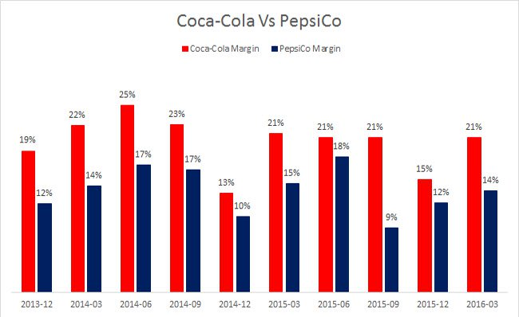
Johnson & Johnson Company and its competitors 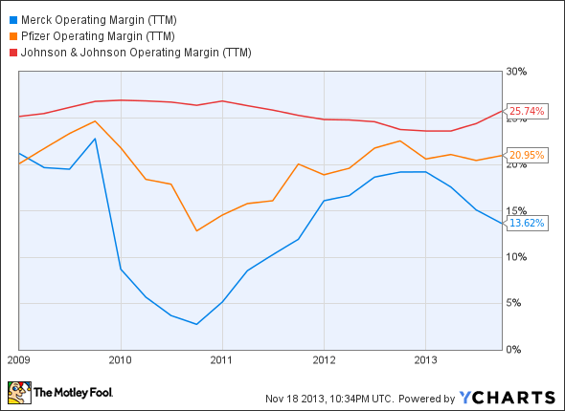
From the graph, both companies lead amongst their major competitors. The two companies has been experiencing different economic trends but still manages to lead other competitive companies due to their pricing uniqueness, sales promotion programs, persuasive advertisements, and increased efficiency in product technique and product innovation. Additionally, it occasionally introduce new packaging, dispensing equipment, new vending, trade mark protection and brand development through sponsorships.
Recommendation for the Analysis
JNJ Company Recommendations
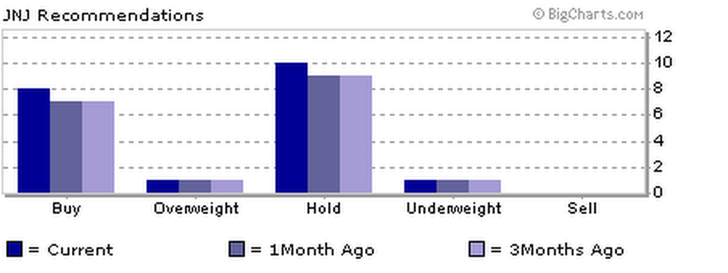
Coca Cola Company Recommendations
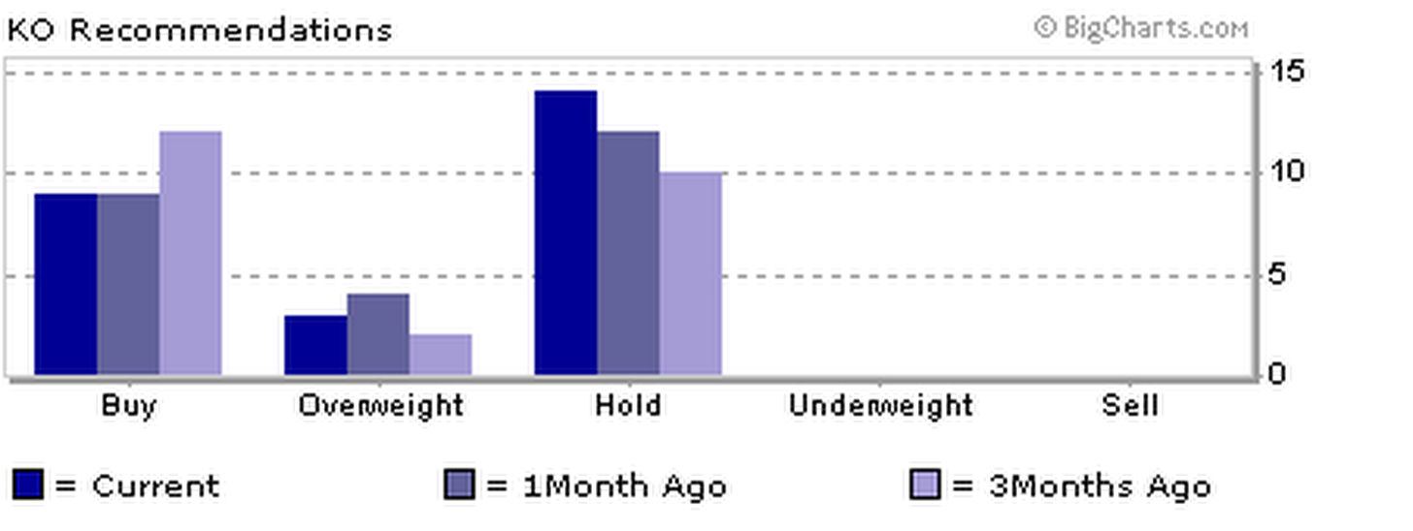
From the analysis of these two companies; Johnson & Johnson Company and Coca Cola Company, I would recommend both Johnson & Johnson Company and Coca Cola Company to, hold. Johnson & Johnson Company is not a good buy currently even though it has an excellent income stock. This makes the stock very expensive and it’s likely to provide a downside. There is also need to normalize the revenue growth trend.
For Coca Cola Company is also not a good buy currently even though it’s still the leading brand among the most valuable brand in the world. It is possible that consumers are changing their tastes and preferences therefore, they are slowly moving away from Coca-Cola brand. Also, it is possible that Coca Cola Company is experiencing its recession period and soon it will bubble up like it always does. Due to this uncertainty, it is not a good buy.

REFERENCES
Borkowski, S. C., Welsh, M. J., & Wentzel, K. (2010). Johnson & Johnson: A model for sustainability reporting. Strategic Finance, 92(3), 29.
Coca-Cola Company (2010) Coke Winning In a Recession. Available from: http://www.coca-cola.co.uk/press-centre/2010/march/coke-winning-in-a-recession.html [Accessed 11 October 2013].
Graham Hubbard, “Measuring Organizational Performance: Beyond the Triple Bottom Line,” Business Strategy and the Environment, December 2006, pp. 177-191.
Henke, R. M., Goetzel, R. Z., McHugh, J., & Isaac, F. (2011). Recent experience in health promotion at Johnson & Johnson: lower health spending, strong return on investment. Health Affairs, 30(3), 490-499.
Mocciaro A., Picone P. & Minà (2012). A Bringing Strategy Back into Financial Systems of Performance Measurement: Integrating EVA and PBC, .Business System Review, Vol 1, Issue 1. Pp.85.
Coca Cola Financial Profile http://finance.yahoo.com/ Accessed October 26th 2012
Turcsanyi, J., & Sisaye, S. (2013). Corporate social responsibility and its link to financial performance: Application to Johnson & Johnson, a pharmaceutical company. World Journal of Science, Technology and Sustainable Development, 10(1), 4-18.

